Project Description:
This is a project which makes the appraisal process transparent. Resource for a particular skill can also be selected. Mysql is the DB used for this project. First the manager assigns task to employees. Next the employee gives a self rating after he/she completes the task. Then Manager approves the rating which automatically reflects in the assignTask table with the rating what employee has given. Manager and employee can see the year end rating by giving the employee Id as input and find the consolidated rating for that employee based on all tasks he had done that particular year. This helps improve performance of the employee. Also in this way the employee gets a correct appraisal based on his/her performance. All his tasks are taken into account which does not miss any work done by the employee to the company.
Screenshots of output:
- Insert into AvailableWorkForce Table if the employee is new
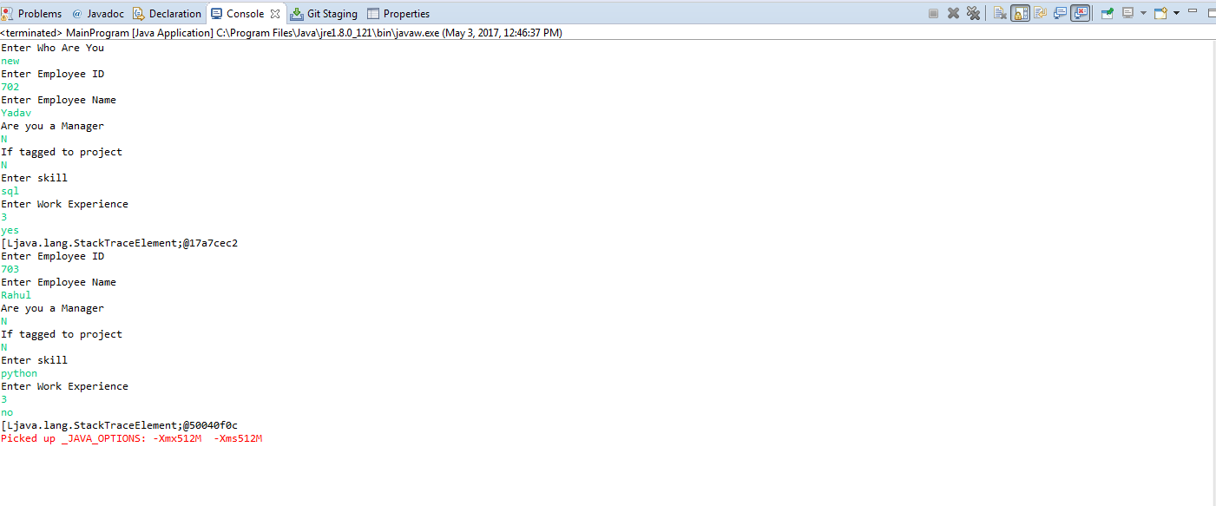
AvailableWorkForce Table:
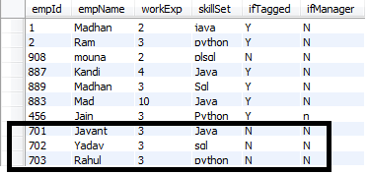

- Manager Assigns task to employee.
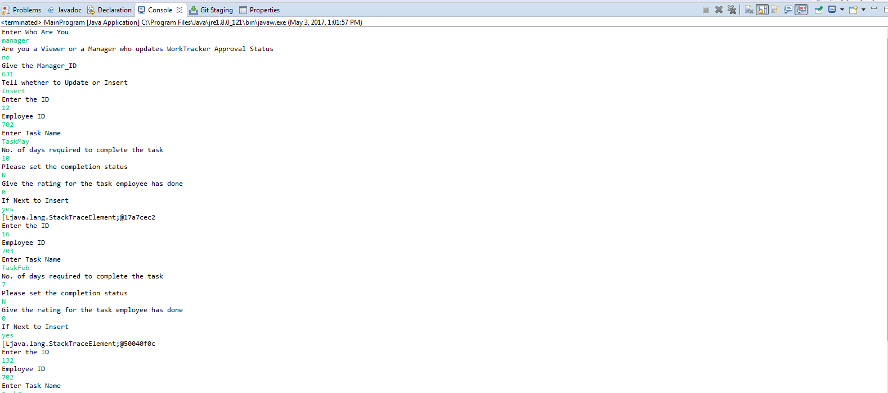

AssignTask Table:
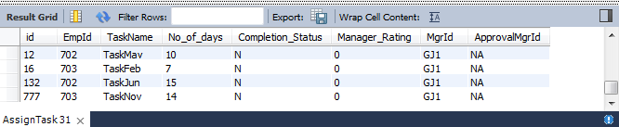

- Now the employee inserts the completion details for that particular task assigned to him/her which will be approved by the manager later. Employee will do a self rating.
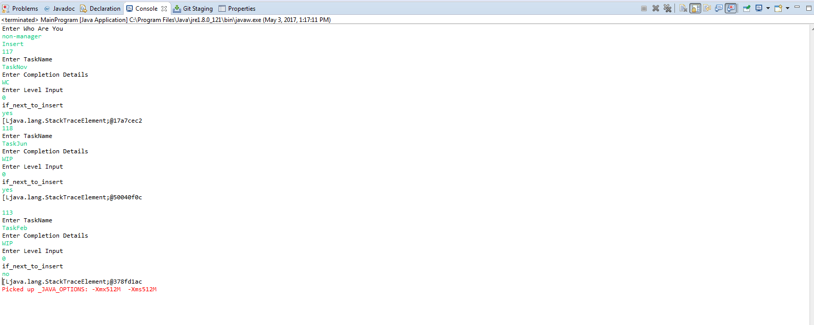
FillDetails table:
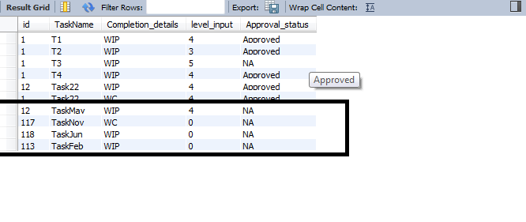

- Employee can update the completion details and the rating for the task she has completed.
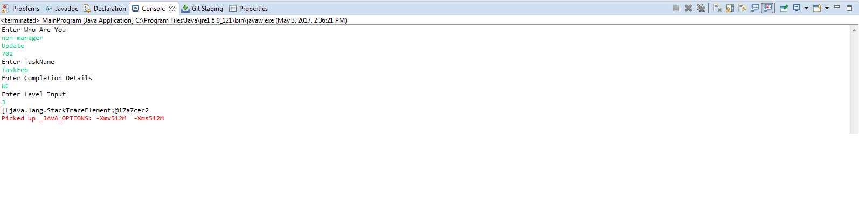
FillDetails Table:
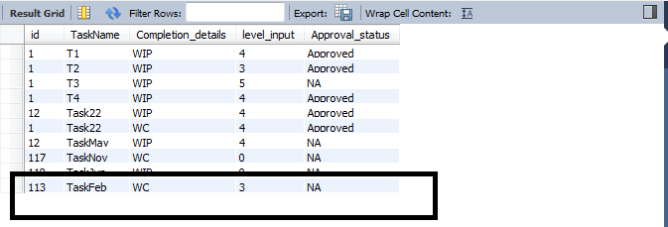
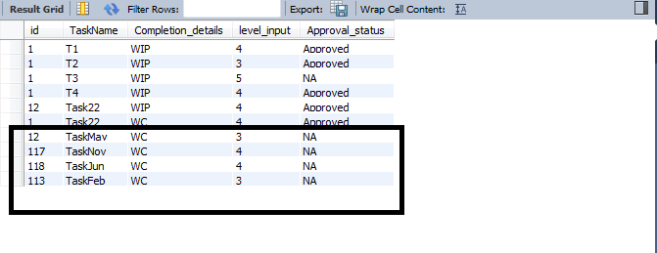
- Manager Approves the self rating given by the employee for the task assigned to him/her. Once the manager approves, the approval_status field in FillDetails table gets updated to “approved”.
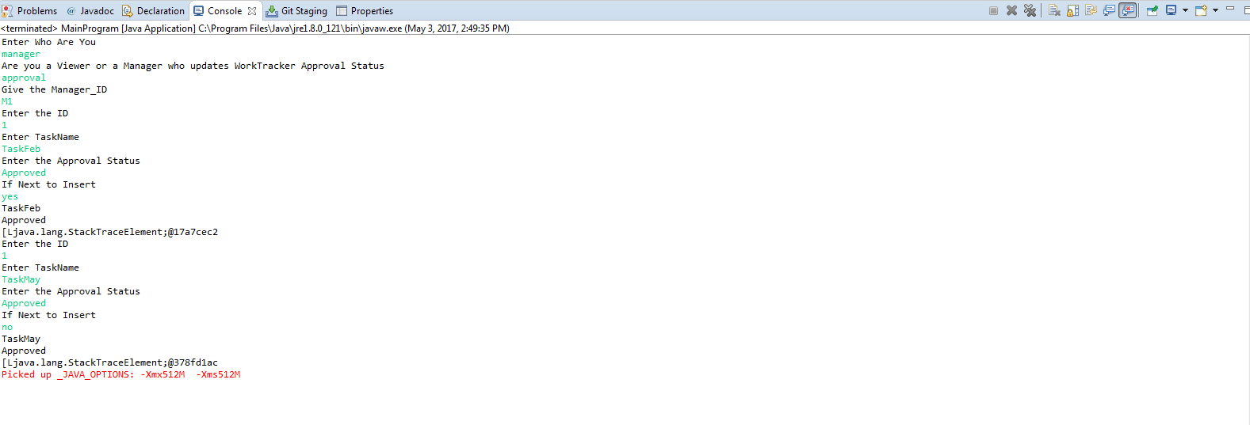

FillDetails: (Field Approval_status is updated)
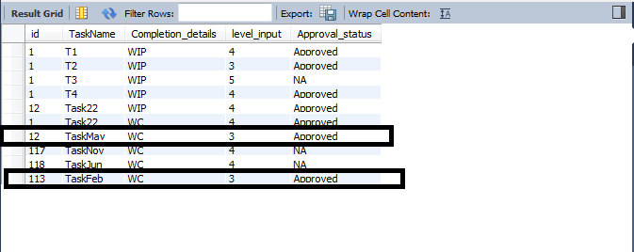

AssignTask Table: (Fields Level_input, Manager_Rating and ApprovalMgId is updated)
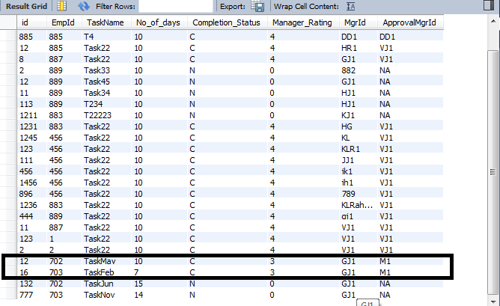

- Finding the average of all ratings for all tasks an employee has done till date.
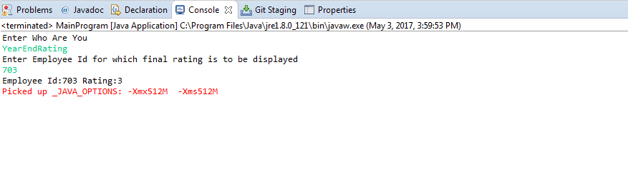

- Manager can view the resources available for a particular skill with a particular work experience.
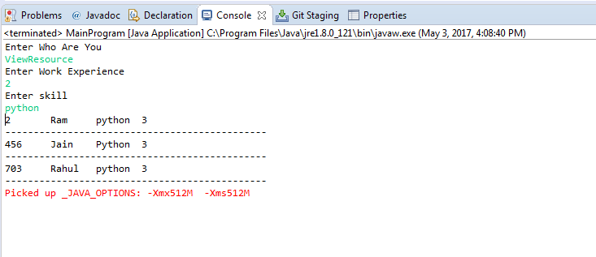
- Allocating resources to projects.
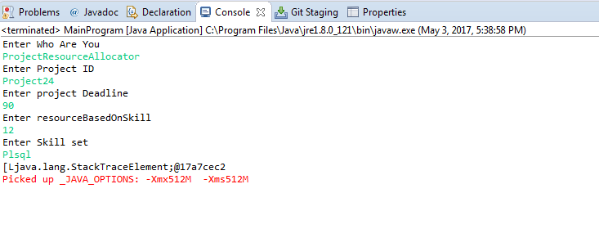
Resource Allocation Table:
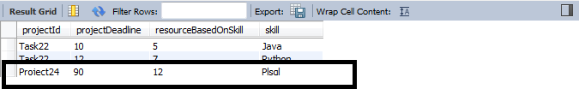

- We can see the difference below after there is a plsql resource allocated to Project24. There is a decrease in the resourceBasedOnSkill field from 12 to 11.
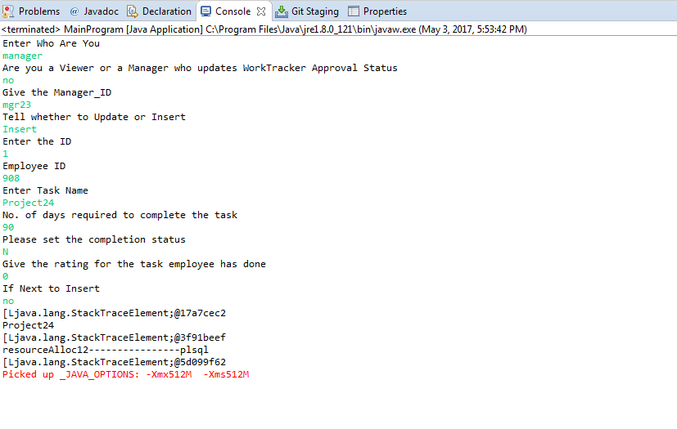
ResourceAllocation table: (resourceBasedOnSkill gets decreased by 11 from 12 after the resource gets allocated)
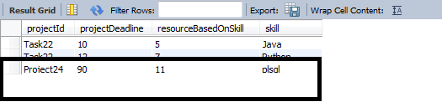
AvailableWorkForce Table: (ifTagged field gets updated to Y after the resource is allocated)
